**LIFE-CYCLE PROCESSES: PART TWO**

**CONFIGURATION MANAGEMENT SYSTEM**

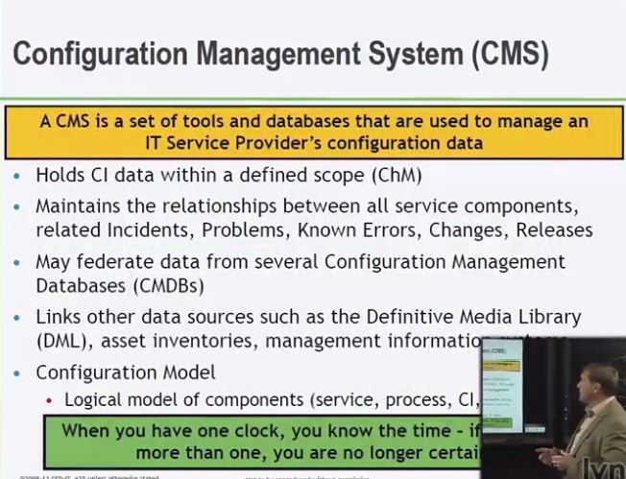

* CAN BE USED FOR ASSESSING CHANGES
* KNOWN ERRORS – PROBLEM TICKET – ROOT CAUSE ANALYSIS – WORKAROUND
* AUDIT OF CONFIG. MAN. SYSTEM
  + CHANGE RECORDS – APPROVED CHANGE RECORDS
* **ATTRITBUTES AND RELATIONSHIPS DATA IS STORED IN A CMDB**

**CMS HAS MULTIPLE CMDB’S**

**(A PART OF THE SERVICE KNOWLEDGE MANAGEMENT SYSTEM SKMS)**

**DEFINITIVE MEDIA LIBRARY**

* INVENTORY OF MEDIA ASSETS

**CONFIGURATION MODEL**

* PLANNING RELEASES
* APPROVING AND ASSESSING CHANGES
* TECH. REFRESHES
* ROOT CAUSE
* INCIDENT MAN.

**CMS** GIVES A SINGLE LOOKING GLASS AT **CMDB’S**

**DEFINITIVE MEDIA LIBRARY**

**(DML) – DEFINITIVE MEDIA LIBRARY**

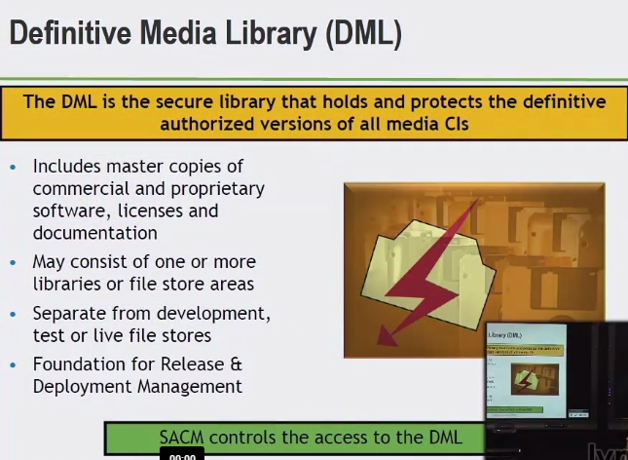

IF IT COMES IN THE SHRINK WRAP BOX, IT GOES IN THE DML (DEFINITIVE MEDIA LIBRARY)

* PURCHASES
* INTERNALLY DEVELOPED
* SOFTWARE

WHAT PROCESSES ACTUALLY *NEED AND USE* SOFTWARE

RELEASE AND DEPLOYMENT MAN. – BUILD TEST AND DELIVER

* SACM CONTROLS ACCESS TO DML

**DEFINITIVE SPARES**

* HARDWARE SPARES

**CHANGE MANAGEMENT**

CHANGES AND DELETIONS IN THE ENVIRONMENT

* ADD NEW SERVICES
* CHANGES TO SOMETHING NOT WORKING PROPERLY

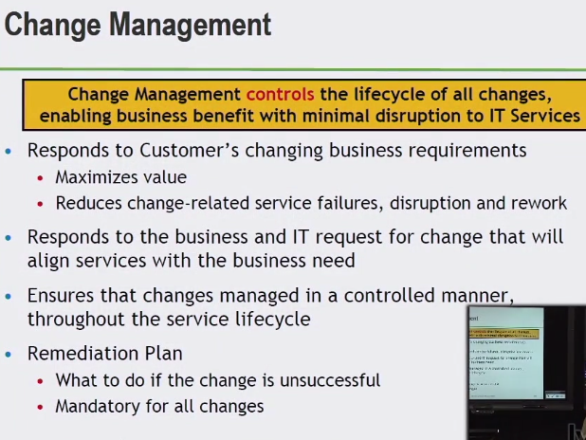

**BUS. EXPECTS**

* CHANGES REQUIRED
* WHEN CHANGES ARE REQ.
* WITH MINIMAL DOWNTIME
* MINIMAL DISRUPTIONS ON CUSTOMER SIDE

IS IT THE RIGHT CHANGE?

DOING IT THE RIGHT WAY?

MINIMIZING RISK?

**LIFECYCLE OF CHANGES**

THROUGH WHEN REQUESTED – DEPLOYED

ENSURE THERE IS REMEDIATION

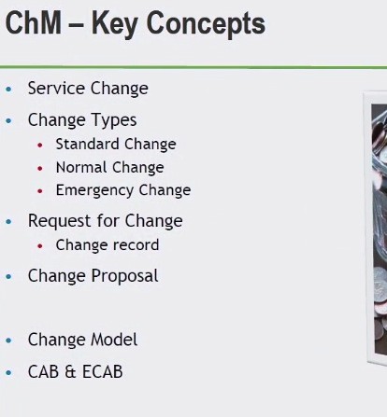

**SERVICE CHANGE**

* ANY ADDITION/MODIFICATION
* REMOVAL AUTHORIZED PLANNED OR SUPPORTED SERVICE SERVICE COMPONONENT CI
* DOCUMENTATION

**STANDARD CHANGE**

* LOW RISK
* WELL UNDERSTOOD
* PREDEFINED SET OF STEPS
* GRANT LOCAL AUTHORIZATION
* LOW RISK TYPE OF CHANGE
* CAN APPROVE AT CHANGE BOARD
* HAS TO HAVE A DEFINED TRIGGER

**NORMAL CHANGE**

* REQUEST, ACCESSED, AUTHROIZED
* CATEGORIZE, PRIORTIZE CHANGES – SEVERITY/PRIORITIES

**EMERGENCY CHANGE**

* OWN CHANGE *MODEL*
* INTENDED TO REACT/DIRECT TO A MAJOR ISSUES
* RESPONSE TO NEGATIVE IMPACT TO BUS.
* HIGH LEVEL CUSTOMER GROUP
* DRIVEN BY SLA’S
* AUTHROITY CLEARLY DOCUMENTED AND UNDERSTOOD RESPONSIBILITIES ON WHO CAN MAKE APPROVALS

**REQUEST FOR CHANGE**

* RFC
* TRIGGER
* OFFICIAL RECOGNITION OF CHANGE REQUEST INITIATED
* FORMAL PROPOSAL FOR CHANGE – DETAILS FOR PROPOSED CHANGE
* ASSESSED BY CHANGE MANAGER TO A CAB
* **CHANGE RECORD –COMES W/ EVERY RFC-**
  + **OFFICIAL DOCUMENT**
  + **CHANGE THROUGHOUT THE LIFE CYCLE**
  + **DETAILS OF CHANGE**

**CHANGE PROPOSAL**

* MAJOR SERVICE TYPE OF CHANGE
* LOOKS AT IMPACT, NEEDS TO BE REVIEWED, AND RESOURCES REQUIRED
* MULTIPLE RFC’S

**CHANGE MODELS**

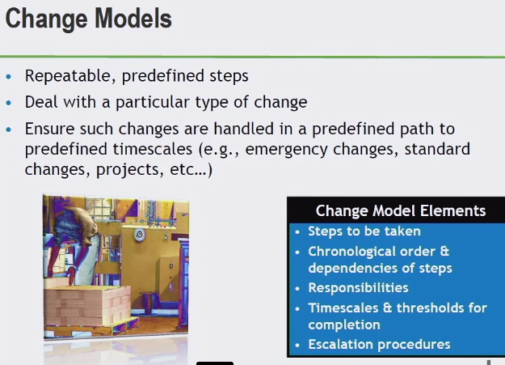

TIME SCALES DRIVEN BY OPS LEVEL AGREEMENTS & SERVICE LEVEL AGREEMENTS

* SINGLE CHANGE PROCESS BUT MULTIPLE CHANGE MODELS TO SUPPORT CHANGE MANAGEMENT

**(CAB) CHANGE ADVISORY BOARD & EMERGENCY ADVISORY BOARD**

**CAB**

* HAVE APPROPRIATE MODELS
* TECHNICAL, BUSINESS, FUNCTIONAL UNDERSTANDING OF CHANGES WE ARE ASSESSING
* PROVIDE MEANINGFUL INPUT ASSIST CHANGE MAN. IN MAKING NEW DECISIONS
* ON HOW WE ARE GOING TO DEAL WITH CHANGE
* APPROVE/DEFER/REJECT
* ASSESS RISK OF CHANGES

(7 R’S OF CHANGE MANAGEMENT)

**CHANGE SCHEDULE**

* WHEN AND WHERE THE CHANGES ARE DEPLOYED

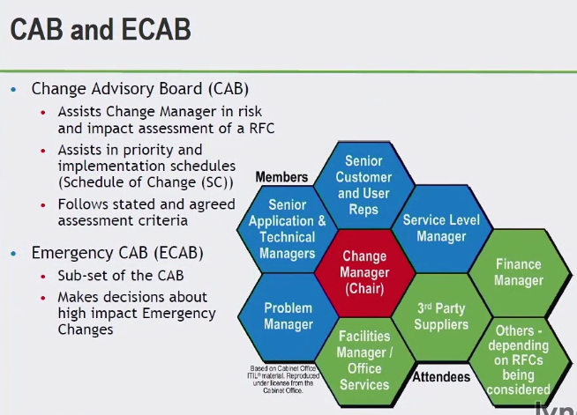

**CAB**

* REGULAR SCHEDULE MEETING
* CAN BE DONE ELECTRONICALLY

**ECAB (EMERGENCY CAB)**

* SUB-SET OF CAB
* ADDRESS HIGH IMPACT EMERGENCY CHANGES
* MIX OF TECHNICAL & AUTHORITY

**ACTIVITIES OF CHANGE MANAGEMENT**

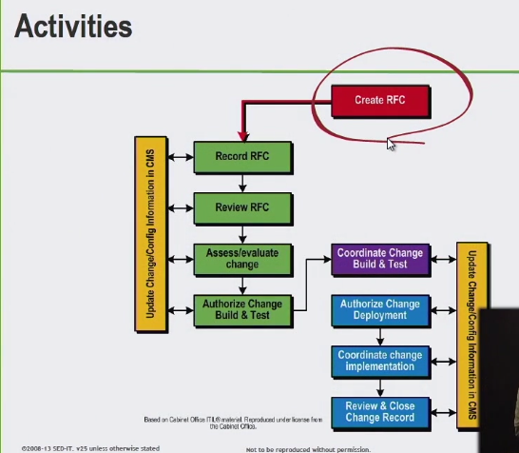

**RFC**

* DONE ON PAPER/ELECTRONICALLY
* OFFICIAL RECOGNITION THAT THAT REQUEST IS BEING MADE

**RECORDED**

* PUT INTO CHANGE MANAGEMENT TOOL

**REVIEW**

* FILTERING DOES RFC HAVE EVERYTHING IT NEEDS
* REMEDIATION
* TEST PLANS

**ASSESS/EVALUATE CHANGE**

* UNDERSTAND TYPE OF CHANGE
* CHANGE MODEL USED
* DIFF. AUTHORITY MIGHT HAVE TO APPROVE
* **CHANGE SCHEDULE (CS)**
* **PROJECTIVE SERVICE OUTAGE (PSO)**

**Do not want to effect service availability**

**Services are unavailable – as a result from change**

**AUTHORITY CHANGE BUILD & TEST**

* FIRST PHASE OF RELEASE AND DEPLOY

**COORDINATE CHANGE BUILD AND TEST**

**AUTHORIZE CHANGE DEPLOYMENT**

**COORDINATE CHANGE IMPLEMENTATION**

**REVIEW AND CLOSE CHANGE RECORD**

**THE SEVEN R’S OF CHANGE MANAGEMENT**

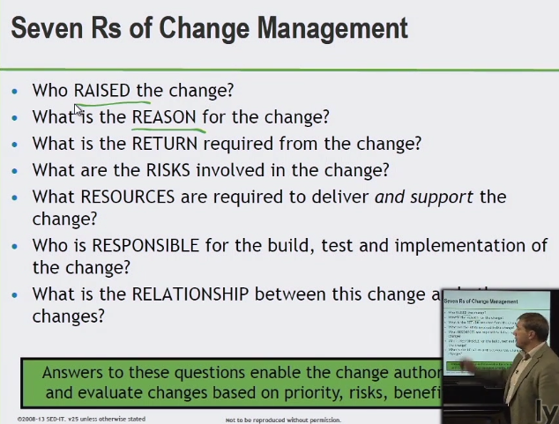

**RAISED**

* CUSTOMER
* INTERNAL/EXTERNAL

**REASON**

* REACTIVE/PROACTIVE
* SIZE OF CHANGE

**RETURN**

* WHAT ARE WE GETTING OUT OF THE CHANGE

**RISKS**

**RESOURCES**

**RESPONSIBLE**

**RELATIONSHIP**

* RELATIONSHIP BETWEEN CONFIGURATION ITEMS
* MAKE SURE THERE ISN’T A COLLISION

**CHANGE MANAGEMENT INTERFACES**

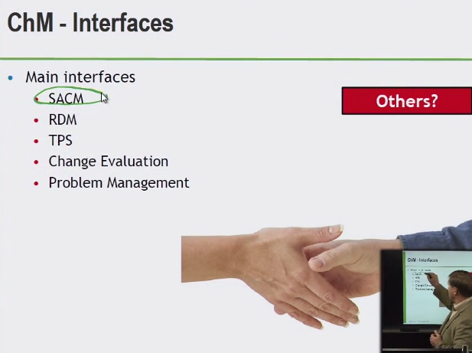

**(SACM) SERVICE ASSET CONFIGURATION MANAGEMENT**

* **CONTROLLING CI’S STORING INFO IN CMS**

**(RDM) RELEASE AND DEPLOYMENT MANAGEMENT**

* **BUILD TEST DEPLOYMENT OF A CHANGE**

**(TPS) TRANSITIONING PLANNING AND SUPPORT**

* **COORDINATION EFFORT FOR TRANSITION PHASE IN GENERAL**

**CHANGE EVALUATION**

* **ENSURING PROVIDING VALUE OF CHANGE**
* **PROVIDED BENEFITS THAT CUSTOMERS ARE EXPECTING**

**PROBLEM MANAGEMENT**

* **WHY WE HAVE A CHANGE IN THE PROCESS**
* **ADVISING IN CHANGE MAN. TO PARTICULAR PROBLEMS THAT MAY ARISE**

**FROM RFC’S COMING IN**

**OTHERS:**

**BUSINESS CHANGE MANAGEMENT (BCM)**

* **ALIGN WITH STRATEGY**
* **COORDINATE ISSUES**

**PROJECT & PROGRAM MANAGEMENT (PPM)**

* **REQUEST FOR CHANGE(S)**
* **SOURCING AND PARTNERING**
* **PORTFOLIO MAN.**
* **CONTINUITY MAN.**
* **SECURITY MAN.**

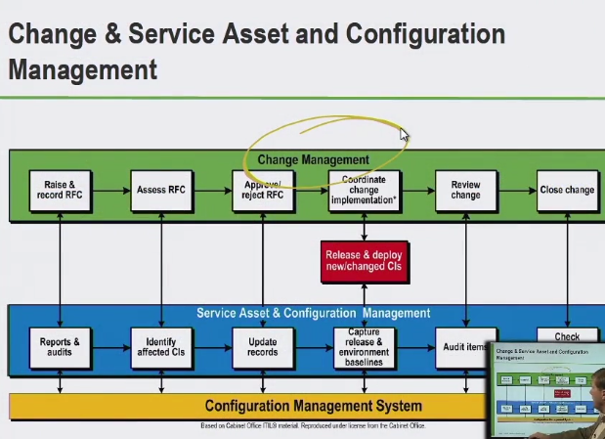

**RELEASE AND DEPLOYMENT MANAGEMENT**

CHANGE – GOING THROUGH APPROVAL

SACM – ENSURING CONTROLLING/KEEPING TRACK OF ASSETS/CONFIG ITEMS

RELEASE AND DEPLOYMENT – BUILDS TESTS AND DELIVERS

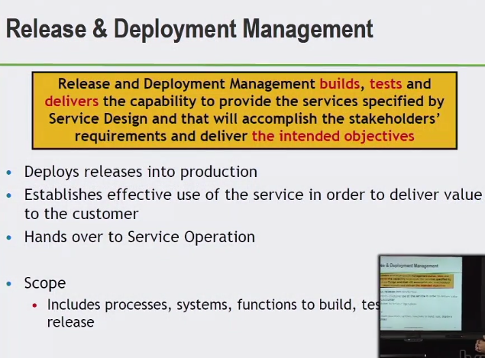

TEST (DEPLOY)

* NEWER CHANGED SERVICE IS MOVING INTO SERVICE OPERATION

**SCOPE**

* RESOURCES

**OBJECTIVES**

* DEFINE AND AGREE ON PLANS WITH STAKEHOLDERS (UNDERSTOOD ACROSS ORG.)
* CREATEING RELEASE AND TEST PACKAGES COMPATIBLE WITH CI’S
* DEFINITIVE MEDIA LIBRARY (DML)
* TRACK INSTALL TEST VERIFY, OR BACKOUT RELEASE PACKAGES

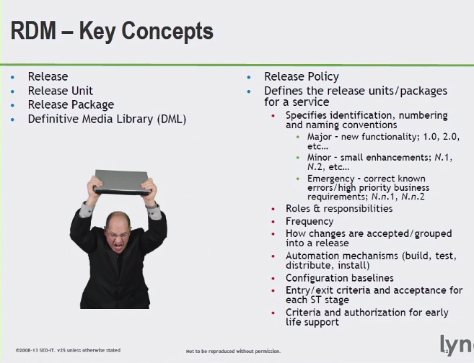

**RDM – RELEASE & DEPLOYMENT MANAGEMENT**

* **BREAK DOWN – DIGESTABLE CHUNKS – FUNCTIONAL CONNECTIONS WITH EACH OTHER**
* **HEIARCHY – RELEASE UNITS – RELEASE PACKAGES**

**DEFINING APPROPRIATE RELEASE PACKAGE TYPE**

**RELEASE PACKAGE**

* SINGLE RELEASE UNIT OR A STRUCTURED SET OF RELEASE UNITS
* ONE OR MORE RELEASE UNIT

**RELEASE UNIT**

* COLLECTION OF COMPONENTS

**DML**

* APPROVED MEDIA CI’S
* STORAGE APPROVED MEDIA CI’S
* INTERNAL OR COMMERCIAL SOFTWARE LICENSES
* CONTROL OF CHANGE MANAGEMENT

**RELEASE POLICY**

* DEFINED ONE OR MORE SERVICES

**THE FOUR PHASES OF RELEASE AND DEPLOYMENT MANAGEMENT**

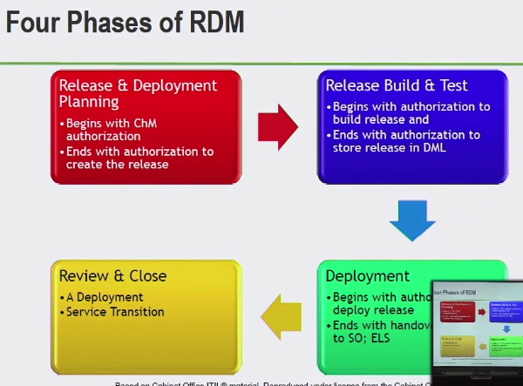

RELEASE & DEPLOY PLANNING

RELEASE BUILD & TEST

REVIEW & CLOSE

DEPLOYMENT

